# Disk Partition and Swap Memory on Suse Linux using UUID

Launch the instance with respective partition volume attached to the instance.

Login to the server and type lsblk command.

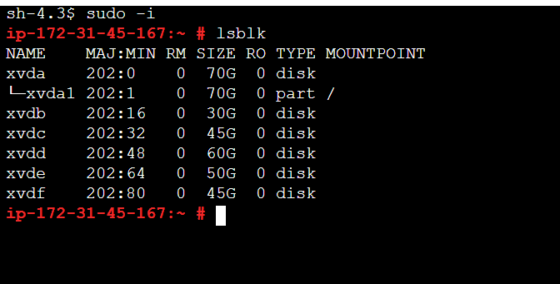

Now the added disk are not mounted in order to mount the disk first we have to format all the added disk except / volume.

Since this is suse linux first we will update the system by using zypper up command.

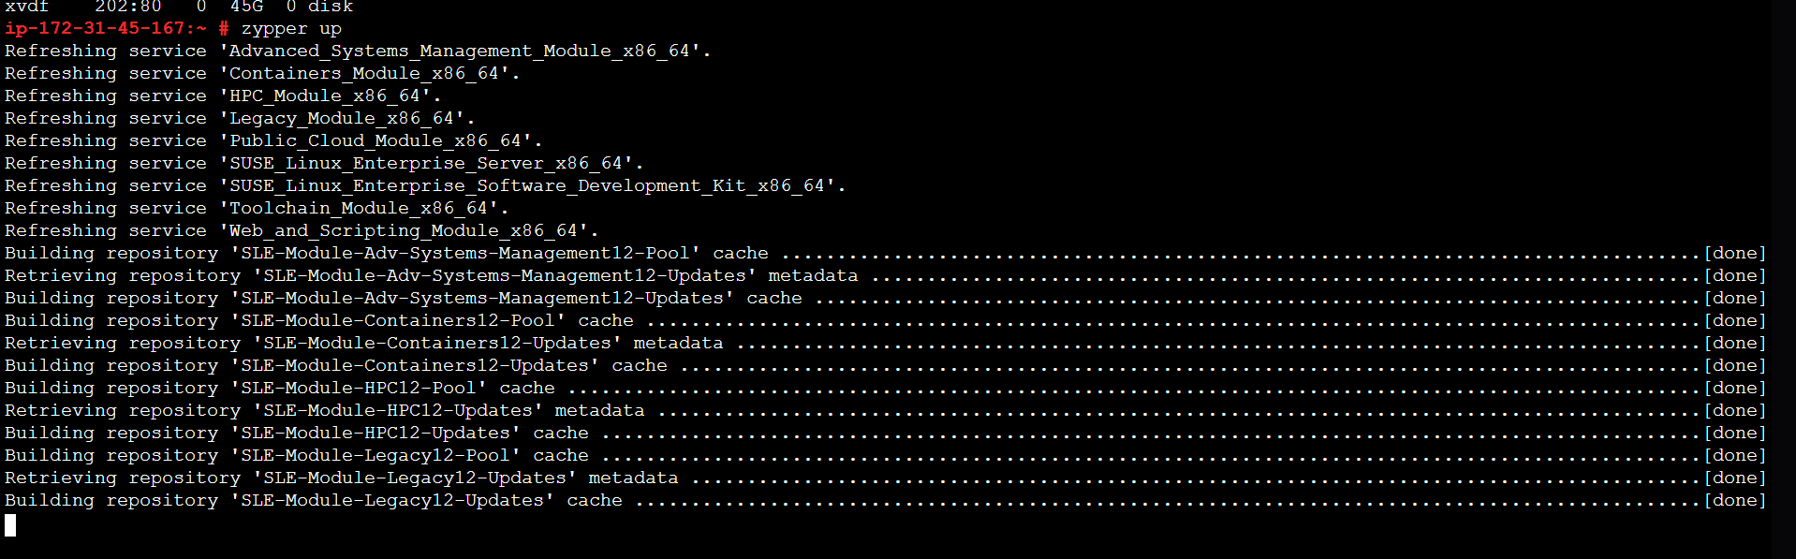

After updating the server type blkid command and check which partition it is,here it is xfs file system

So we have to format each volume with xfs file system.



Now format each disk volume by typing this command mkfs.xfs /dev/xvdb

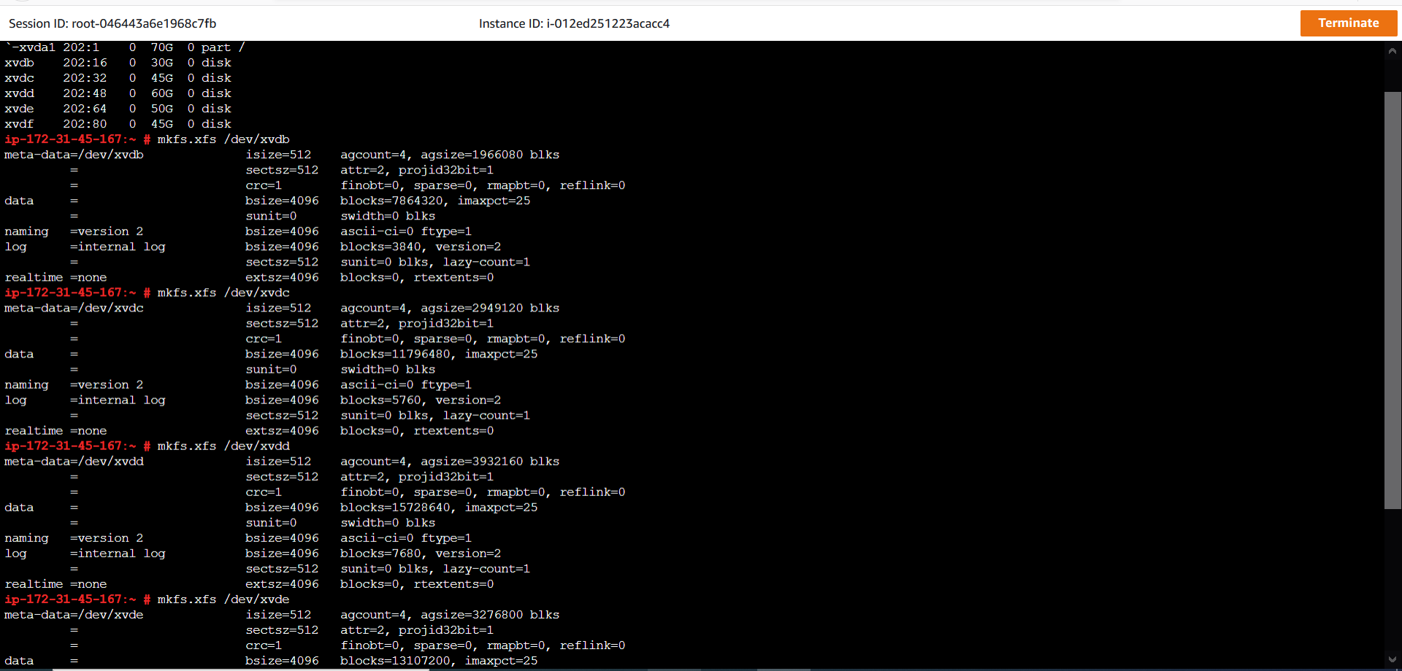

After you format the disk volume check if it is formatted are not ,if the disk is formatted you will able to see the disk UUID,if it is not formatted properly uuid won’t be visible

To verify all the disk volumes are formatted type the command blkid.

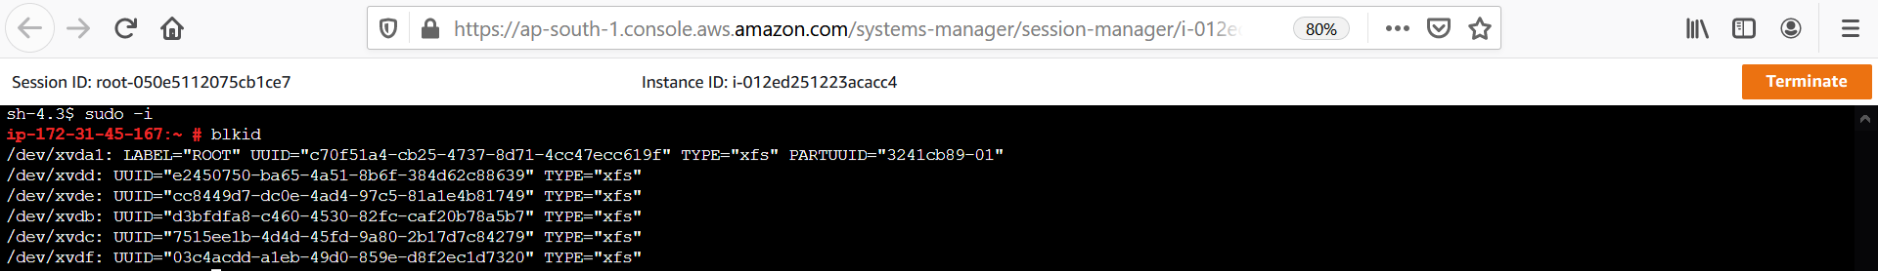

Now all the disk are formatted.

Now before procceding further, create the respective directories that needs to be mounted.

Now I created the directories as mentioned below screenshot.

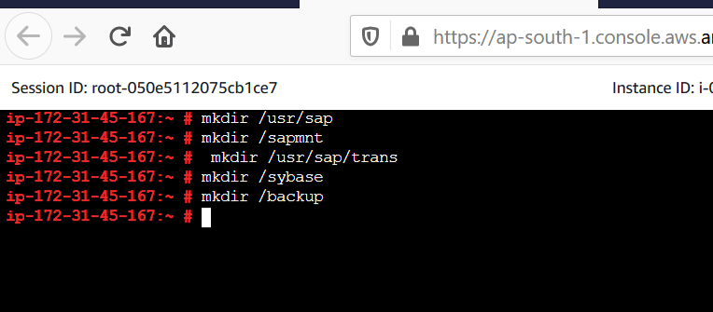

Now mount the disk volumes as per the requirement

Command to mount the disk volume is mount /dev/xvdb /usr/sap .

This mounting which we did below is just temporary mounting as shown below.

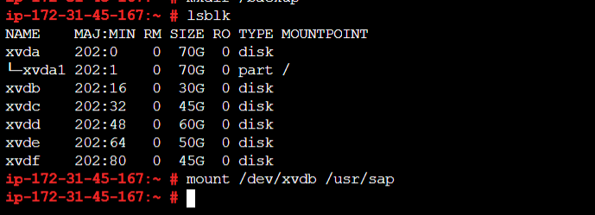

What we did till now is temporary mounting,if this mounting should be permanent you need to update it in vi/etc/fstab, we are mounting this using UUID,so type the command blkid to get the UUID of the disk volume

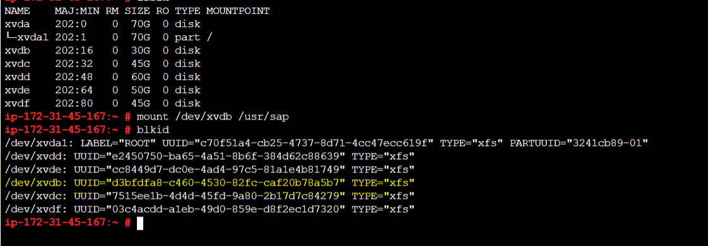

Now we got the blkid of the particular disk volume ,now we need toupdate the mounting point and UUID in the fstab

Now go to vi/etc/fstab to update the required mounting details to do permanent mounting

UUID=d3bfdfa8-c460-4530-82fc-caf20b78a5b7 /usr/sap xfs defaults 0 0

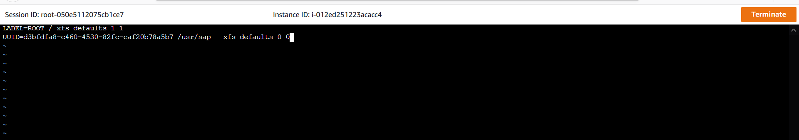

Now save it using wq!

The changes to happen in fstab type mount –a as shown in the below screenshot.



To verify it is mounted or not type the command lsblk

Now u can see the mount point below screenshot,this show that it is mounted properly.

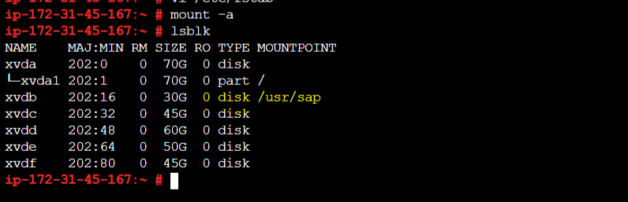

Similary do it for other disk volumes.

Now I have mounted all the disk volumes as shown below.

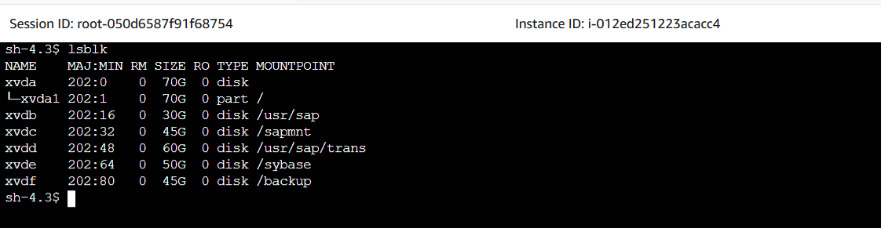

Now we are going to add swap memory to this server.

There are some rules for setting up swap memory

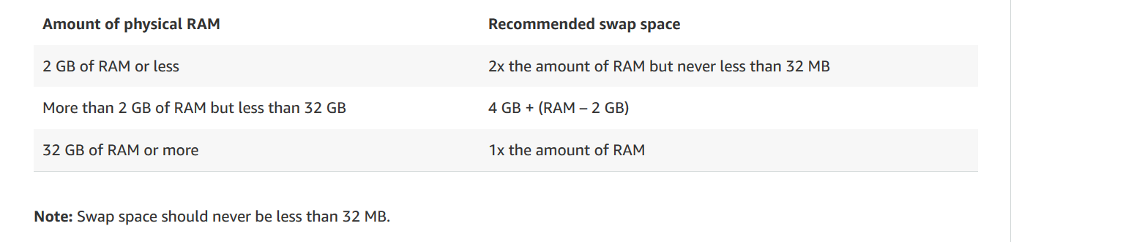

**Create a swap file**

1.    Use the **dd** command to create a swap file on the root file system. In the command, **bs** is the block size and **count** is the number of blocks. The size of the swap file is the block size option multiplied by the count option in the **dd** command. Adjust these values to determine the desired swap file size.

The block size you specify should be less than the available memory on the instance or you receive a "memory exhausted" error.

In this example **dd** command, the swap file is 4 GB (128 MB x 32):

$ sudo dd if=/dev/zero of=/swapfile bs=128M count=32

2.    Update the read and write permissions for the swap file:

$ sudo chmod 600 /swapfile

3.    Set up a Linux swap area:

$ sudo mkswap /swapfile

4.    Make the swap file available for immediate use by adding the swap file to swap space:

$ sudo swapon /swapfile

5.    Verify that the procedure was successful:

$ sudo swapon -s

6.    Enable the swap file at boot time by editing the **/etc/fstab** file.

Open the file in the editor:

$ sudo vi /etc/fstab

Add the following new line at the end of the file, save the file, and then exit:

/swapfile swap swap defaults 0 0

I used this command to add swap memory as per the rules given below.

My instance ram is 1GB so I used this below command to add swap memory.



To check swap services is working fine are not

User free –m

